The Flourish Model
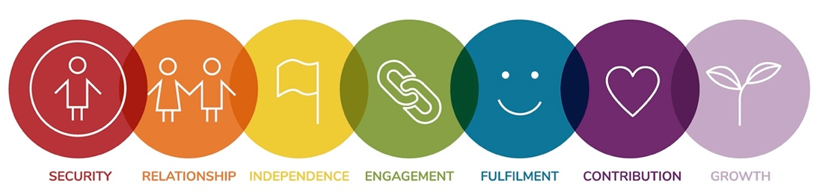
____________________________________________________________
The Flourish Wellbeing Measure introduces an interdisciplinary road map to better understand the relational foundations of human capacities and potential and to promote and optimise sustainable wellbeing. Underpinned by the science of human evolution, development, behaviour, and flourishing, it promotes an ecological understanding of the Self as intimately connected to Others and the Natural World.
In other words, it shows how we are all connected and how we can work together to create a more caring and sustainable world.
__________________________________________________________________________________
Why was it created?
It was created in response to the fact that none of the existing global measures of wellbeing at that time were fully:
a) focusing on what optimised wellbeing in the first place – i.e. the relational conditions that we need to flourish in the earliest years of life

b) looking at the needs that we share as one human family, living on a finite planet

c) giving proportionate value to the negative, stressful or unpleasant periods of life that balance the periods of positive experience/psychology and that enable us to better understand our own patterns, overcome difficulties and develop resilience and empathy for others

d) honouring the evolutionary human process and the physical, emotional, mental and spiritual aspects that shape integrated human lives

e) recognising the importance of understanding each community as a vibrant living system, within which the wellbeing of every aspect matters to the whole

