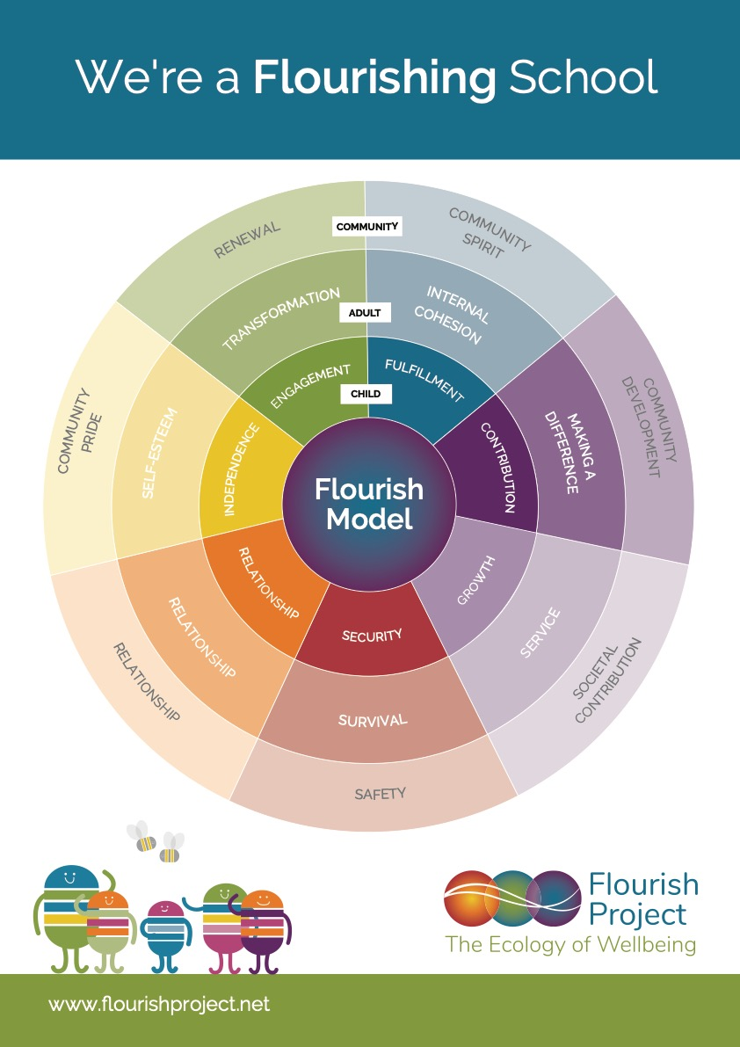

**Our Seven Core Principles**

* We care about our role in safeguarding the planet
* We are compassionate and nurture each other
* We can express ourselves in multiple ways
* We are being encouraged to learn and grow
* We are developing our unique skills and abilities
* We have honest and caring relationships
* We feel safe in our school and classrooms